Purpose
For individuals experiencing substance misuse the road to recovery is often made more difficult because of an uncoordinated and hard to access system of services and resources. The Lazarus Collaborative (the Collaborative) Pilot Project will enable residents in the core area of Mat-Su up through Big Lake/Sutton to have the support of a Collaborative Care Coordinator (CCC) and access to a collaborative network of providers to address their needs, increase access to services, remove barriers, and promote coordinated care. This collaborative will decrease the amount of time it takes for clients to initiate care focused on promoting resilience and integration into the community while improving their quality of life. It is recognized that medical, social (i.e., food, housing, income, transportation), psychological, and emotional/spiritual supports are necessary for long-term recovery. The Lazarus Collaborative will increase access to, coordinate, and deliver those supports.

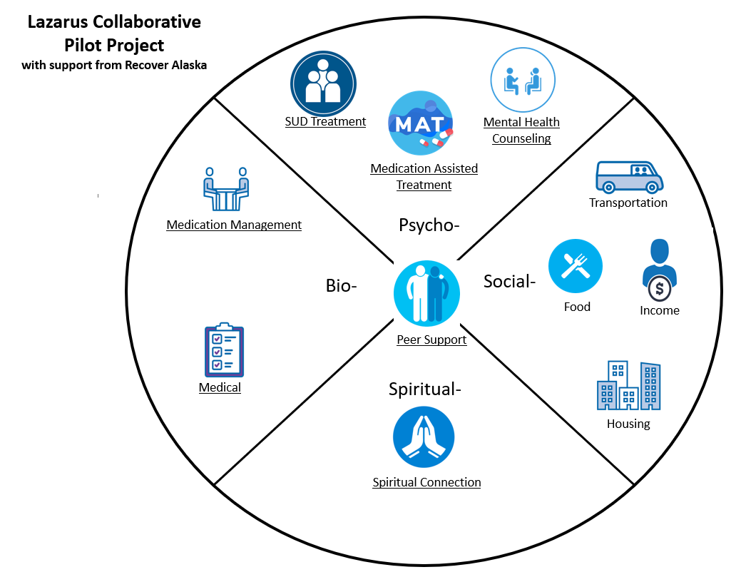
This Memorandum of Understanding (MOU) outlines the key responsibilities of the partners in the Collaborative, as well as the targeted outcomes.

Targeted Outcomes

Clients/Patients (Participants)
Participants will receive the following services as needed:
- Timely access to care goals:
  - CCC support within 72 hours
  - Support with obtaining social needs within 72 hours
  - Medical care:
    - Primary care within 48 hours
  - Behavioral health care:
    - Crisis support housing within 7 days
    - Residential detox within 7 days
    - Medication Assisted Treatment within 7 days
    - Mental health care starting within 14 days (screening, assessment, intake, and treatment started).
    - Substance Use Disorder (SUD) care within 7 days (screening, assessment, intake, and treatment started)
    - Medication management within 14 days
- Coordinated care:
  - The CCC will be able to successfully communicate with the Collaborative offices/organizations within 24 hours of initiating contact.
  - Collaborative partners will return phone calls with other providers within 24 hours of the initial call.
  - Collaborative members will discuss cases at monthly Multidisciplinary Team Meetings (MDT).

- An appropriate level of SUD treatment care: All participants will receive an SUD screening/ assessment and will be assisted with obtaining the appropriate level and type of care. These services will include detox, screening, brief intervention, and referral to treatment (SBIRT), crisis stabilization, case management, intensive case management, SUD
care coordination, community recovery support services, as well as assessment and traditional outpatient (OP), intensive outpatient (IOP), 3.1 and residential services when appropriate. Also, including appropriate mental health care.

Collaborative Providers
Collaborative providers will report:
- A better understanding of the services and resources that exist in their community to serve their patients/clients.
- Improved communication with other providers and an expanded network of provider relationships.
- Increased understanding of the potential to use the 1115 Waiver for billing services.
- All providers will receive training, as requested, in the delivery of trauma-informed care.
- Increase satisfaction with patient/client care of collaborative participants.

Collaborative Members: LIST ALL MEMBERS HERE

Participant Eligibility
An individual will be eligible to participate in this pilot project if they have or are at risk for a substance or polysubstance misuse and/or a mental health-related problem; they are 18 years or older; and they live in the core area of Mat-Su (through Big Lake/Sutton). While there is no insurance requirement, an effort will be made to have participation from 50% or more of individuals with Medicaid coverage.

Referral into the Pilot Project
Referrals for participants can come from any member of the collaborative and will be initiated by contacting _________________ at (907) ________ . Referrals will also be accepted as “walk-ins.” A participant will be contacted within 24 hours of receipt of the referral by a CCC to initiate services.

Agreements
Meetings: Collaborative providers agree to meet monthly for up to 90 minutes to discuss cases, issues related to the functioning of the collaborative, and review data findings for the pilot project.

Timely Care: Collaborative providers agree to provide timely care as defined in the Targeted Outcomes section of this MOU.

Communication:
- Providers will communicate with each other to discuss participant care via phone, email and fax A provider will return a communication attempt (phone call, etc.) within 24 hours or less. Once ROI is signed providers will ensure all communication regarding care will comply with Health Insurance Portability and Accountability Act (HIPAA) standards.

- The CCC will communicate with service providers to secure appointments and services for the participants through identified front office staff and intake coordinators. These frontline staff will return a CCC call within 24 hours or less.

Billing:
Each organization will be responsible for billing for their own services in accordance with applicable conditions of participation.

Multi-Disciplinary Meeting (MDT)
- It is the responsibility of providers to always meet all HIPAA & 42CFR Part 2 compliance requirements.
- It is the responsibility of providers to accept and adhere to the ROI on all clients prior to case presentations.
- It is the responsibility of MDT members to attend and contribute to monthly meetings. Contributions are measured in the following manner:
  - Regular attendance to scheduled meetings.
  - Six case submissions per calendar year per organization.
  - Members share case-related data.
  - Members provide HIPPA compliant appropriate and reliable means of communication.
  - Members participate in evaluation of MDT process.
  - CCC will be responsible for documenting system and process improvements.
  - Provider will be responsible for entering referral or follow-up information into their electronic health record as appropriate.
  - No provider will bill for MDT meetings.

Data Sharing:
- Collaborative members will agree to a shared Release of Information (ROI) that will have the names of all collaborative members. At initiation of services, the collaborative member in contact with the participant will have them sign the shared ROI. A copy of this ROI will be sent to and kept by the CCC at ___________. The CCC will alert all providers participating in the participant’s care that a signed ROI is on file and will share that ROI as they help a participant seek services with specific providers.

- Actionable Data Consulting (ADC) will collect data on participants to measure the targeted outcomes for the project. Agreed upon measures will be included as an addendum to the MOU. Recover Alaska will not be involved in the MDT meetings, data analysis or receive any identified data.

- Collaborative members agree to share tools, forms and other resources with other providers/organizations/collaboratives who are providing similar services in an effort to spread this type of support.

Terms of the Agreement
This agreement will begin __________________, and last until _______________.

Each party takes legal and financial responsibility for the actions of its respective employees, officers, agents, representatives, and volunteers. Each party agrees to indemnify, defend and hold harmless the other parties to the fullest extent permitted by law from and against any and all demands, claims, actions, liabilities, losses, damages, and costs, including reasonable attorney’s fees, arising out of or resulting from the indemnifying party’s acts or omissions related to its participation under this Memorandum of Agreement, and each party shall bear the proportionate cost of any damages attributable to the fault of such party, its officers, agents, employees and independent contractors. It is the intention of the parties that where fault is determined to have been contributory, principles of comparative fault will be applied.

Each party, at its sole cost and expense, shall carry insurance or self-insure to cover its activities in connection with this MOU, and obtain, keep in force, and maintain, insurance or equivalent programs of self-insurance, for general liabilities, workers compensation and business automobile liability adequate to cover its potential liabilities hereunder.

Amendments to the MOU
All parties reserve the right to renegotiate the MOU upon the mutual consent of the other parties. Any party may submit requests to the Collaborative through the ADC facilitator for consideration to amend the MOU. The participating organizations’ respective decision-making authorities will need to approve any amendment. All members must approve any amendments. Collaborative members may discontinue participation in this collaborative and MOU by notifying T___________. It is requested that providers alert the Collaborative 30 days prior to discontinuing participation.

This Memorandum represents the entire understanding of all parties with respect to this collaborative effort.

Effective Date and Signature

1.

_____________________________________ ______________________________________
Printed Name and Title Signature

_________________________________________________ ________________
Organization Date

2.

_____________________________________ ______________________________________
Printed Name and Title Signature

_________________________________________________ ________________
Organization Date

3.

_____________________________________ ______________________________________
Printed Name and Title Signature

_________________________________________________ ________________
Organization Date
4.

____________________________________ ______________________________________
Printed Name and Title Signature

_________________________________________________ ________________
Organization Date

5.

_____________________________________ ______________________________________
Printed Name and Title Signature

_________________________________________________ ________________
Organization Date

6.

_____________________________________ ______________________________________
Printed Name and Title Signature

_________________________________________________ ________________
Organization Date

7.

_____________________________________ ______________________________________
Printed Name and Title Signature

_________________________________________________ ________________
Organization Date

8.

_____________________________________ ______________________________________
Printed Name and Title Signature

_________________________________________________ ________________
Organization Date

9.

_____________________________________ ______________________________________
Printed Name and Title Signature

_________________________________________________ ________________
Organization Date

10.

_____________________________________ ______________________________________
Printed Name and Title Signature

_________________________________________________ ________________
Organization Date

